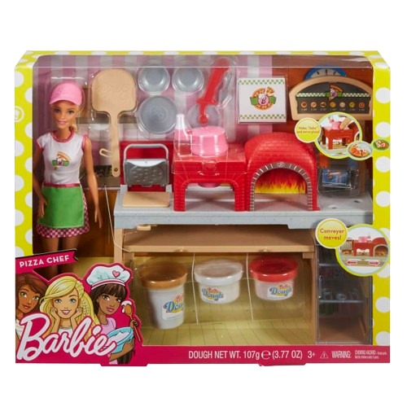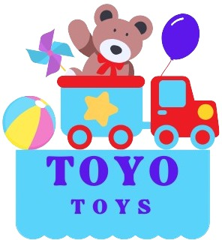

**Barbie Pizza Chef**

**Price: $14.99**

**Where style meets endless possibilities!**

* **Comes with over 25 cooking tools and ingredients**

**Step into the world of culinary creativity with the Barbie Pizza Chef set. This exciting playset lets kids explore their love for cooking with endless pizza-making fun and accessories.**

**Product details**

**THANK YOU!**

**WELLCOME TO OUR WEBSITE**